Aim:
1a. Write a Python code to print your profile. (Format output in a pretty way)
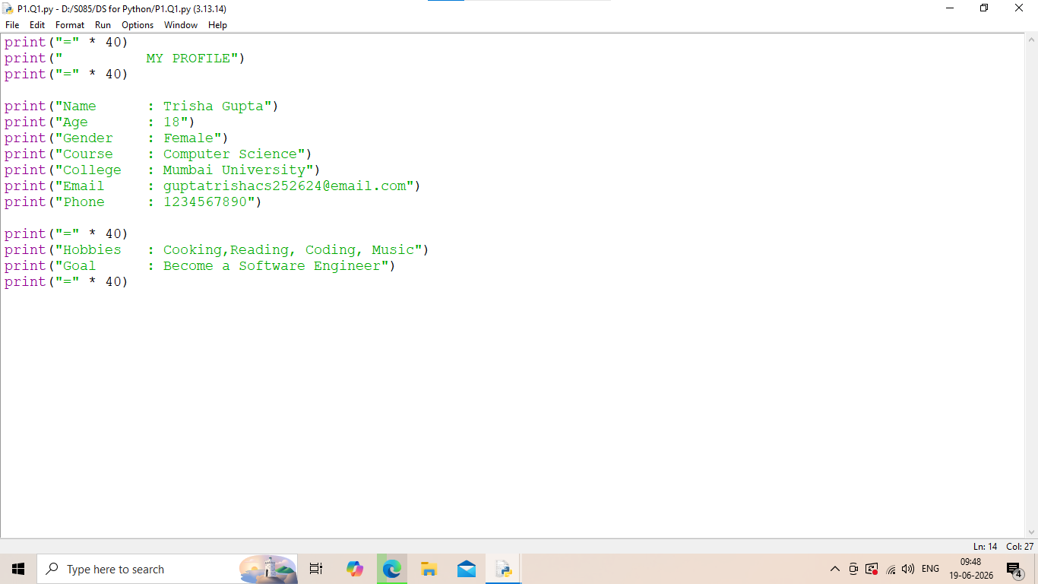
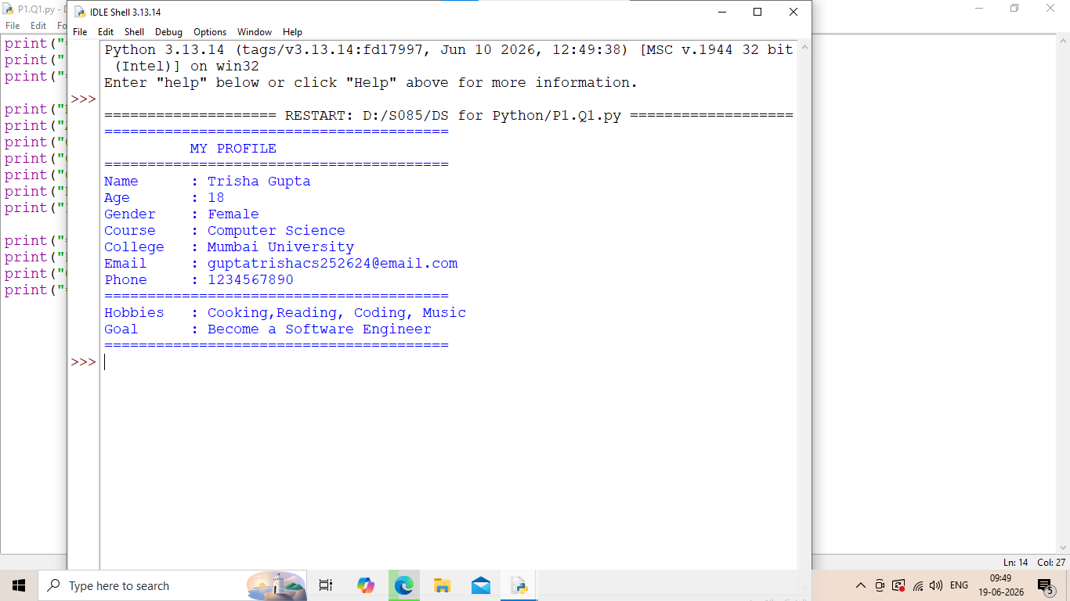

1b. Write a Python code to print the addition of two numbers. (Take input of a list of numbers and print their total using the sum() function)
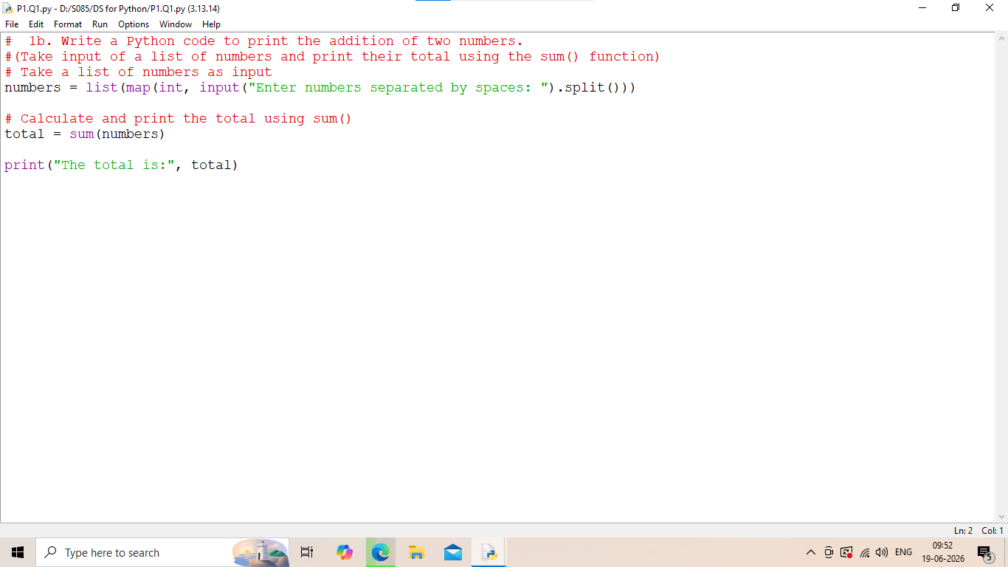
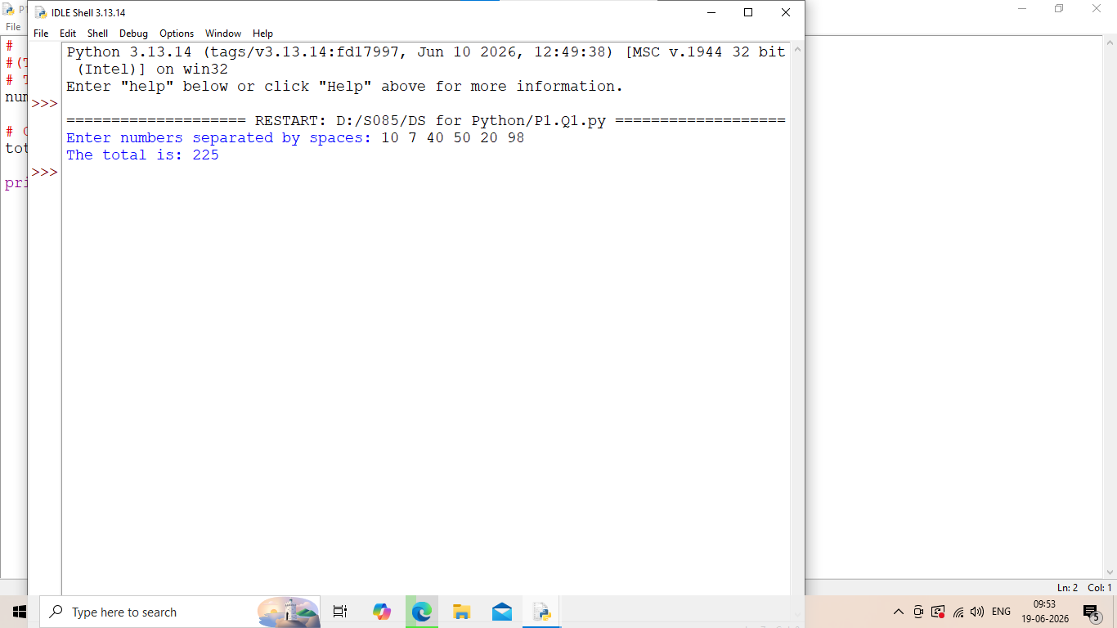

1c. Write a Python code to print the square root of number. (Take user input and use a loop to compute square roots for multiple values and use try-except to handle invalid inputs.)
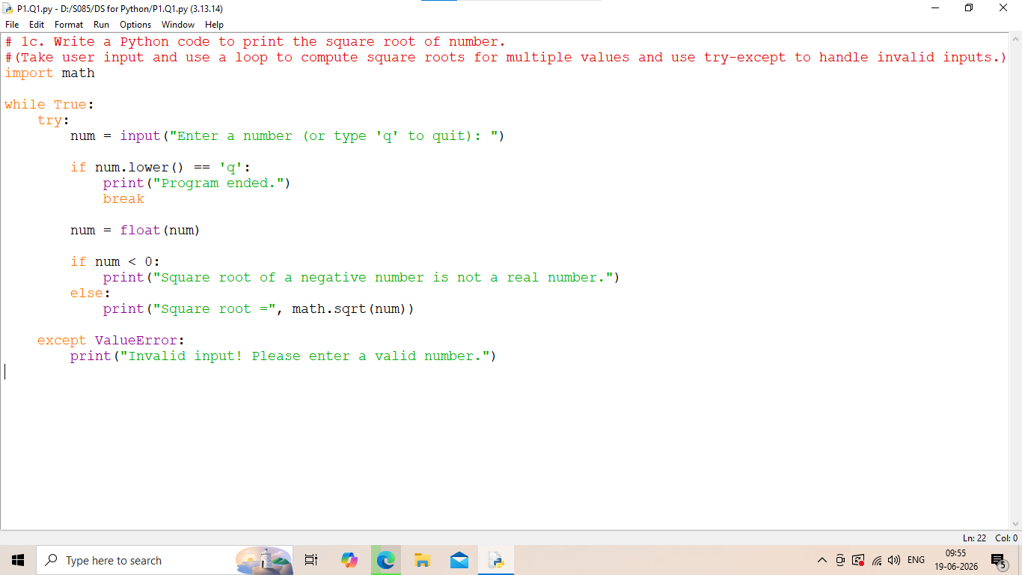
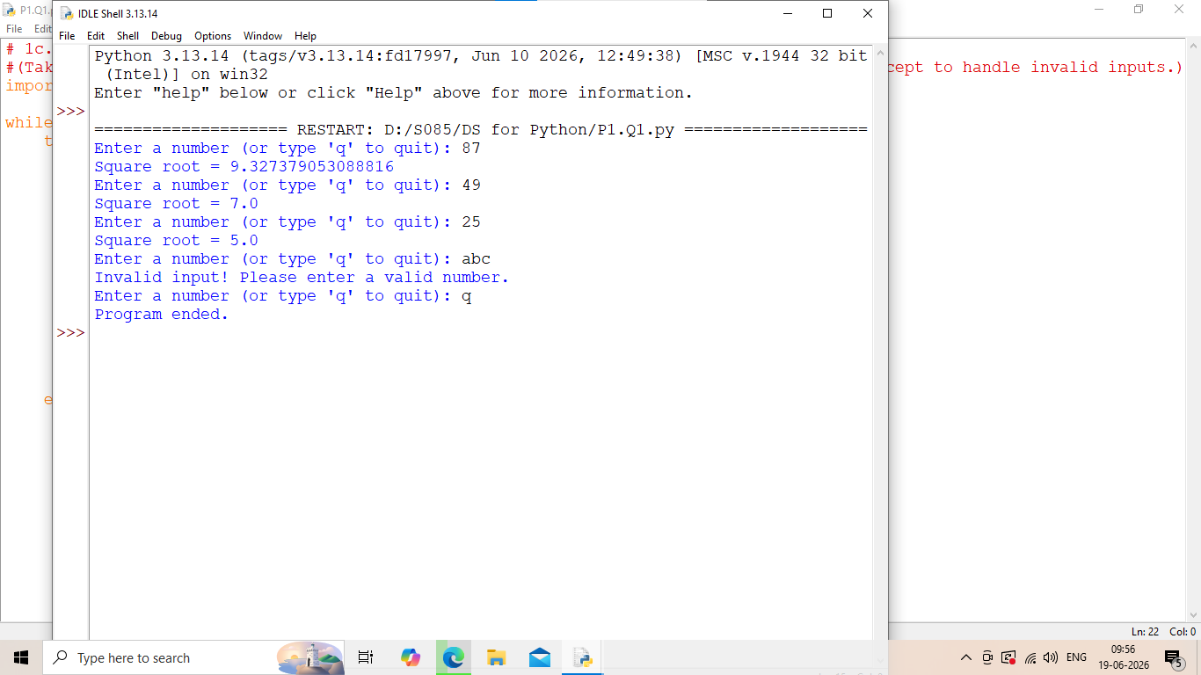

1c. Write a Python code to calculate area of Triangle.
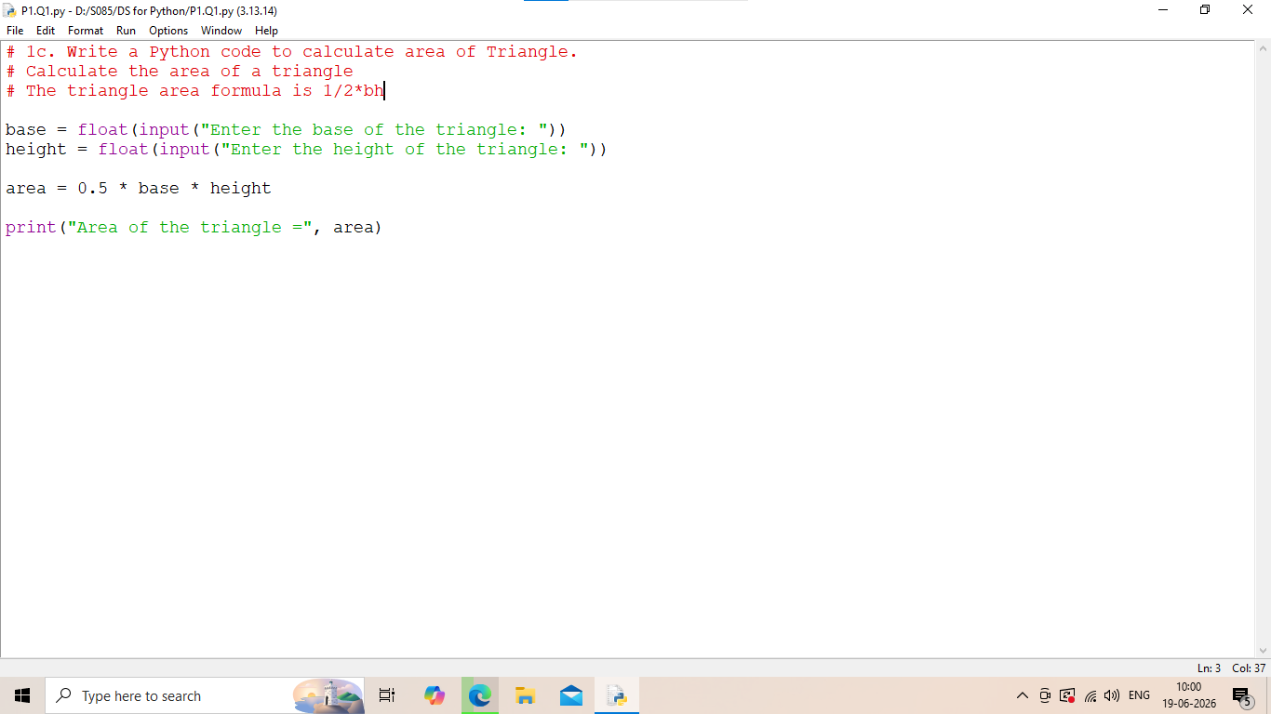
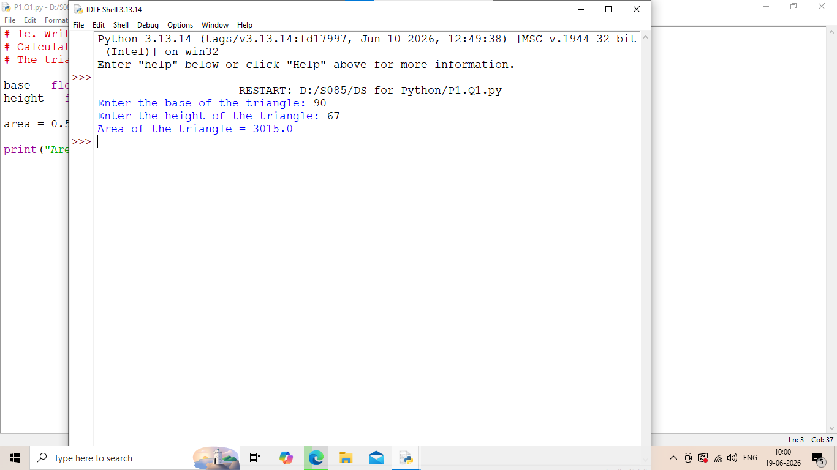

1d. Write a Python code to swap two variables. (Write a function that swaps any two elements in a list using indexing and print the updated list).
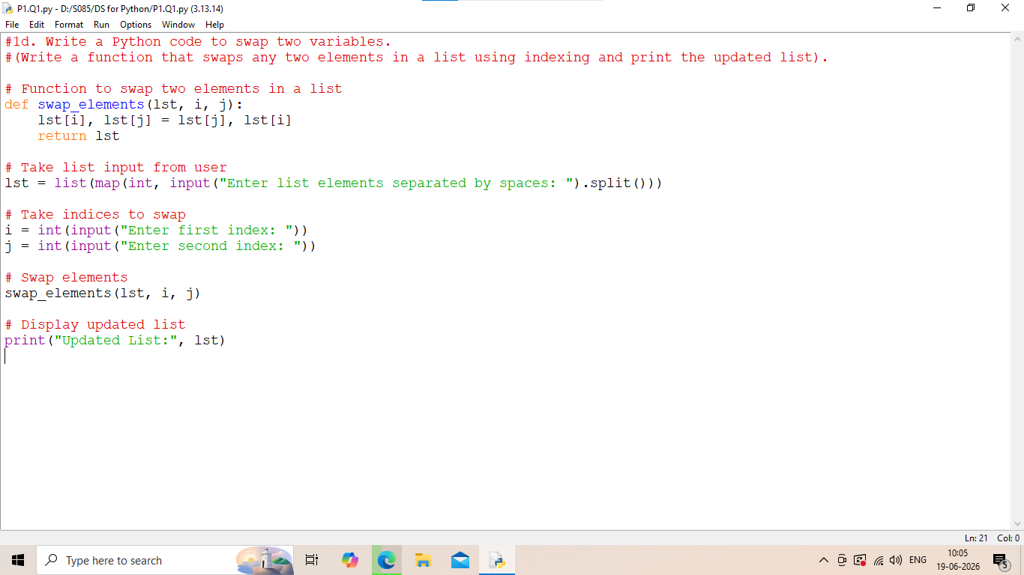
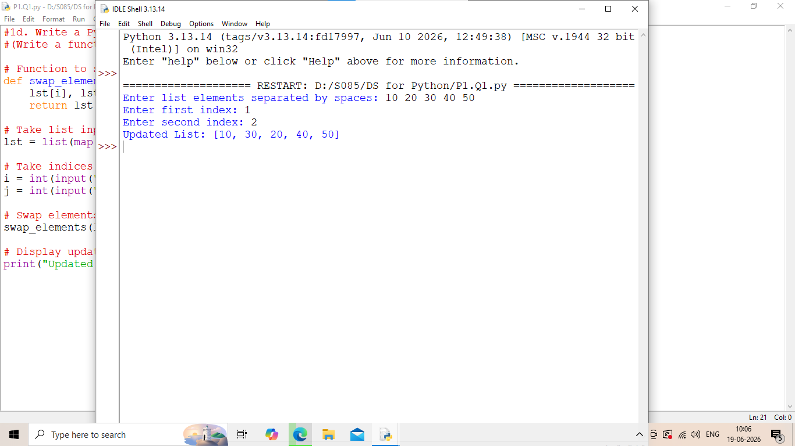

1e. Write a Python program that takes a sentence as input and counts the number of words and characters, converts the sentence to lowercase and uppercase, and replaces all spaces with underscores (_).
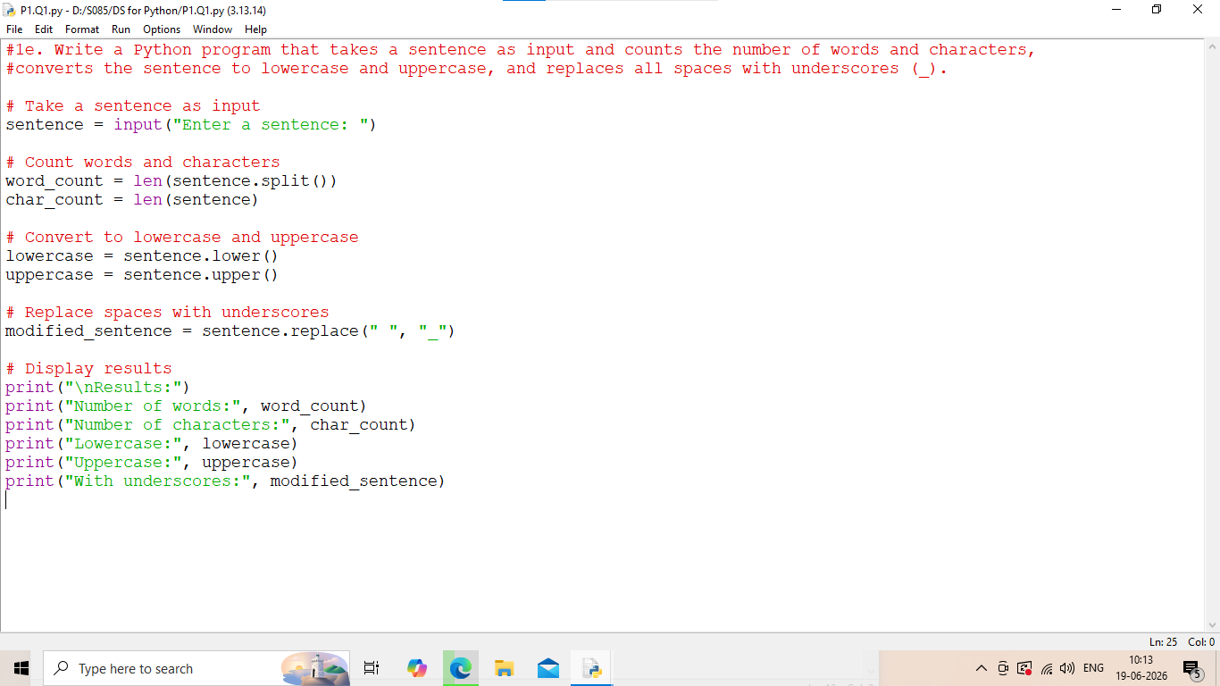
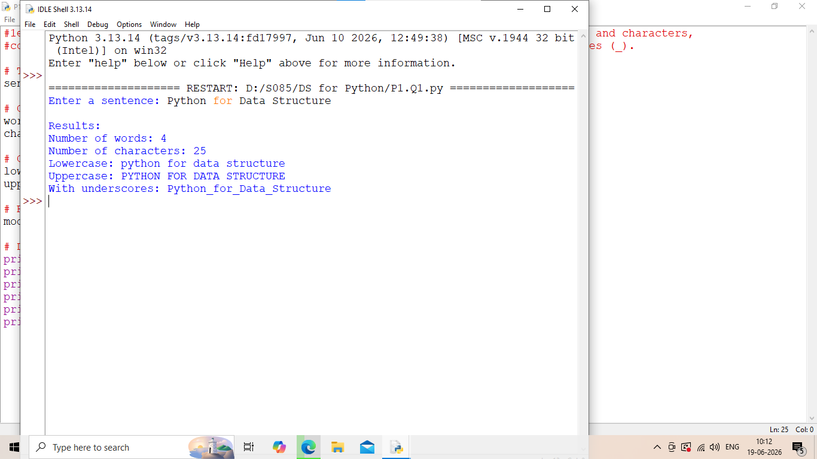

1f. Create a list of 10 numbers. Write a program to find the maximum, minimum, and average, sort the list in ascending and descending order, and add a new number to the list and remove the first item.
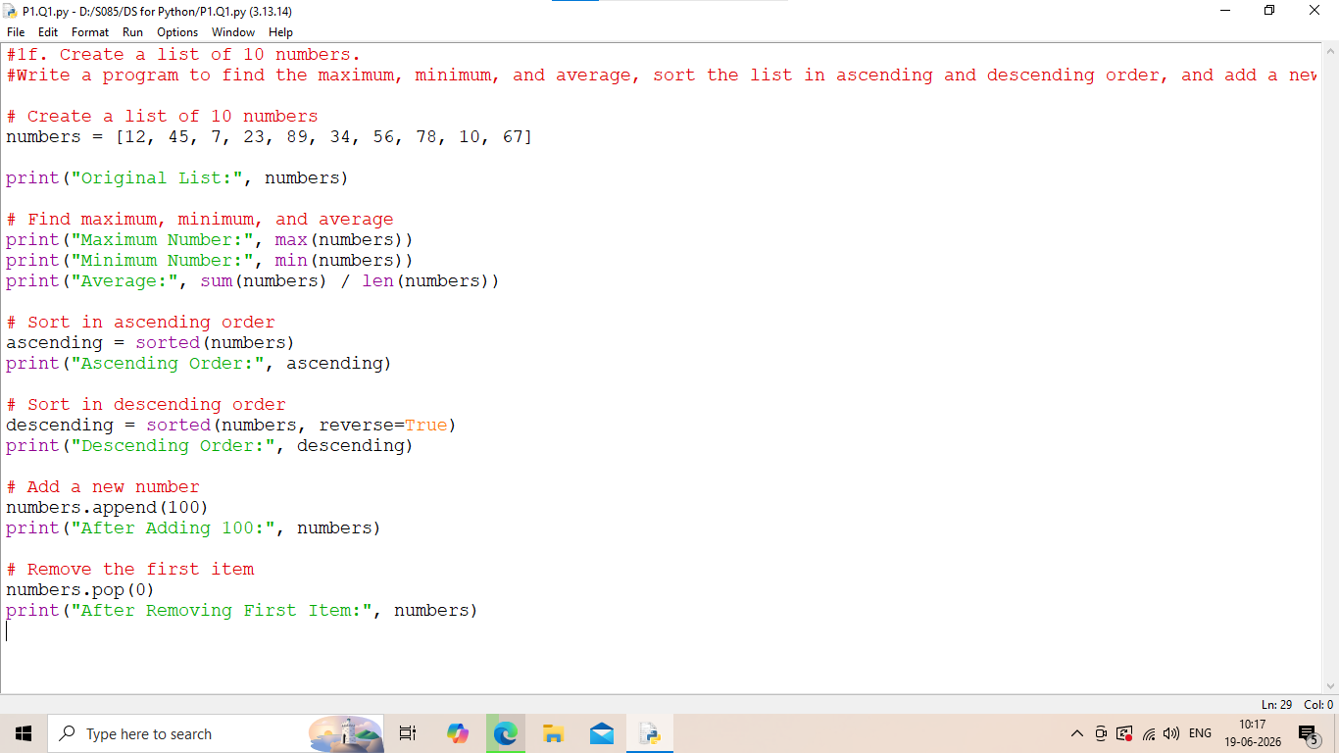
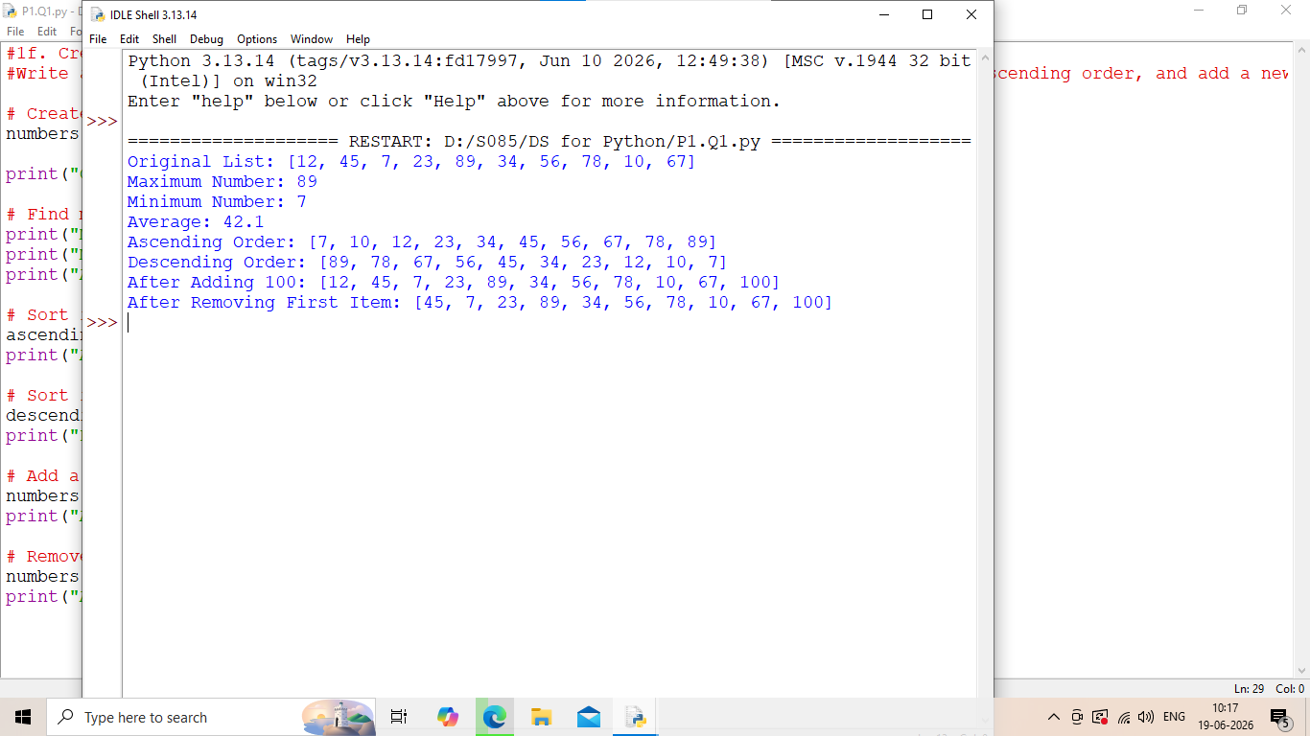

1e. Store the names and marks of 5 students in a dictionary and then print each student’s name and marks, calculate and print the class average, and find the student with the highest marks.
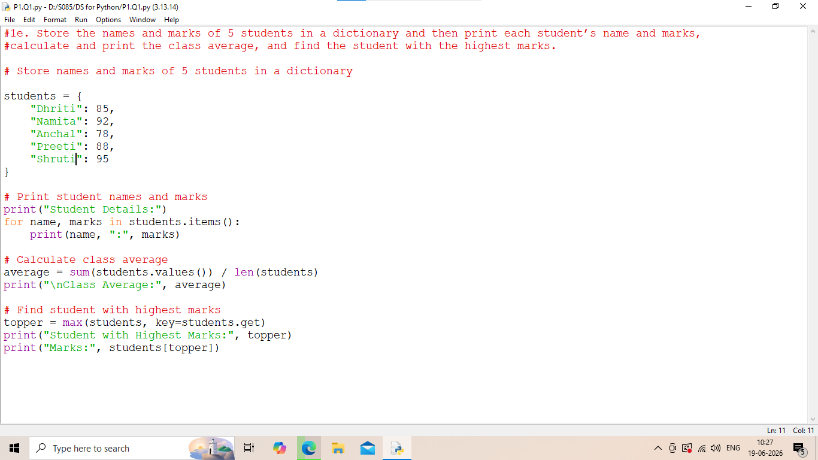
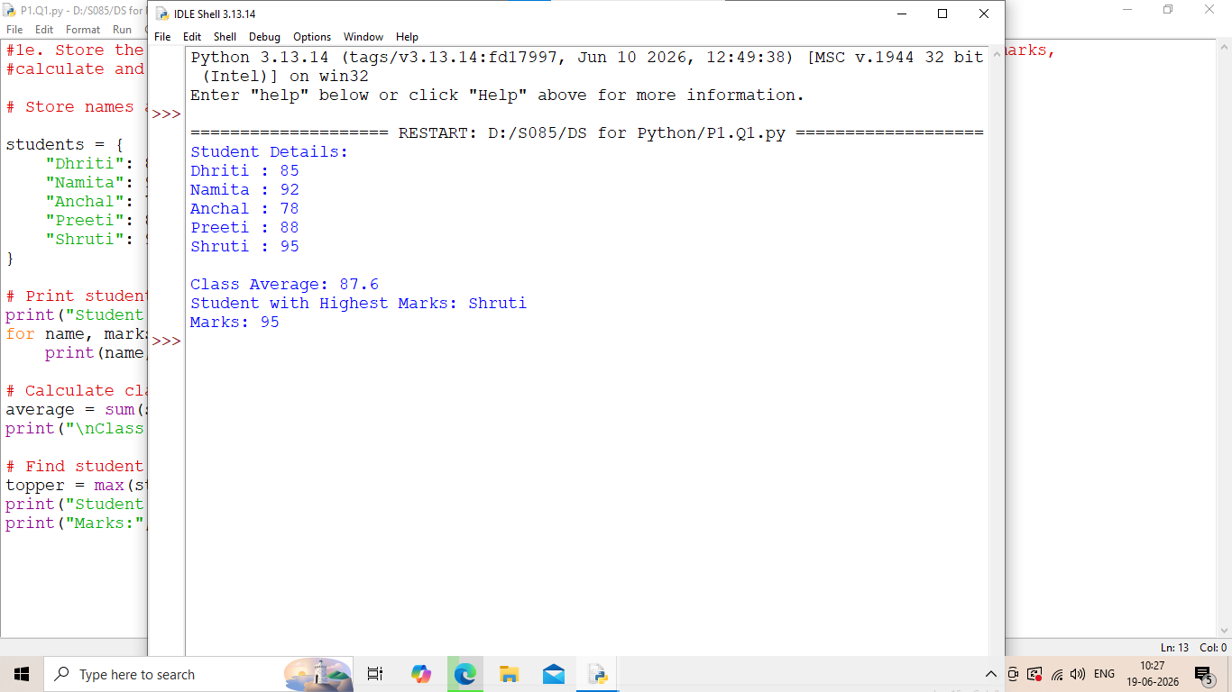

1g. Write a Python program that accepts marks as input and prints the grade as 90+ = A, 75–89 = B, 50–74 = C, below 50 = Fail.
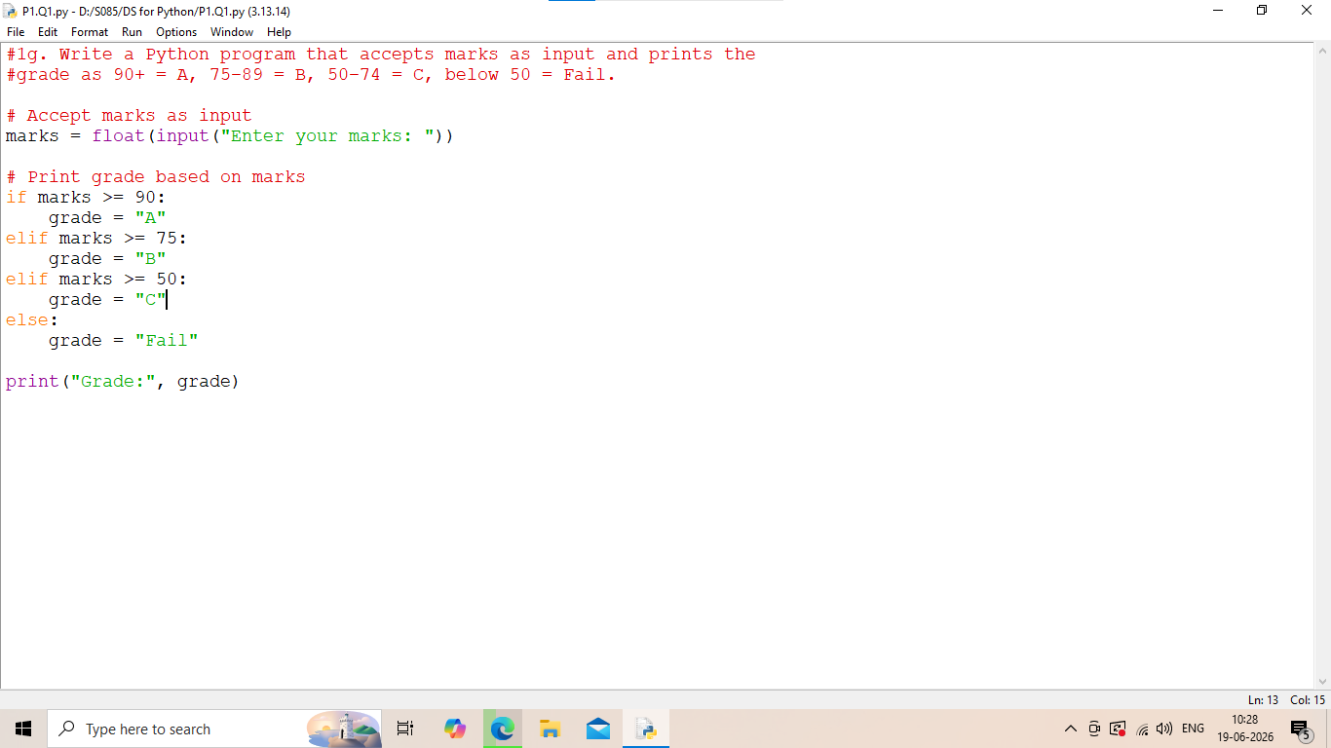
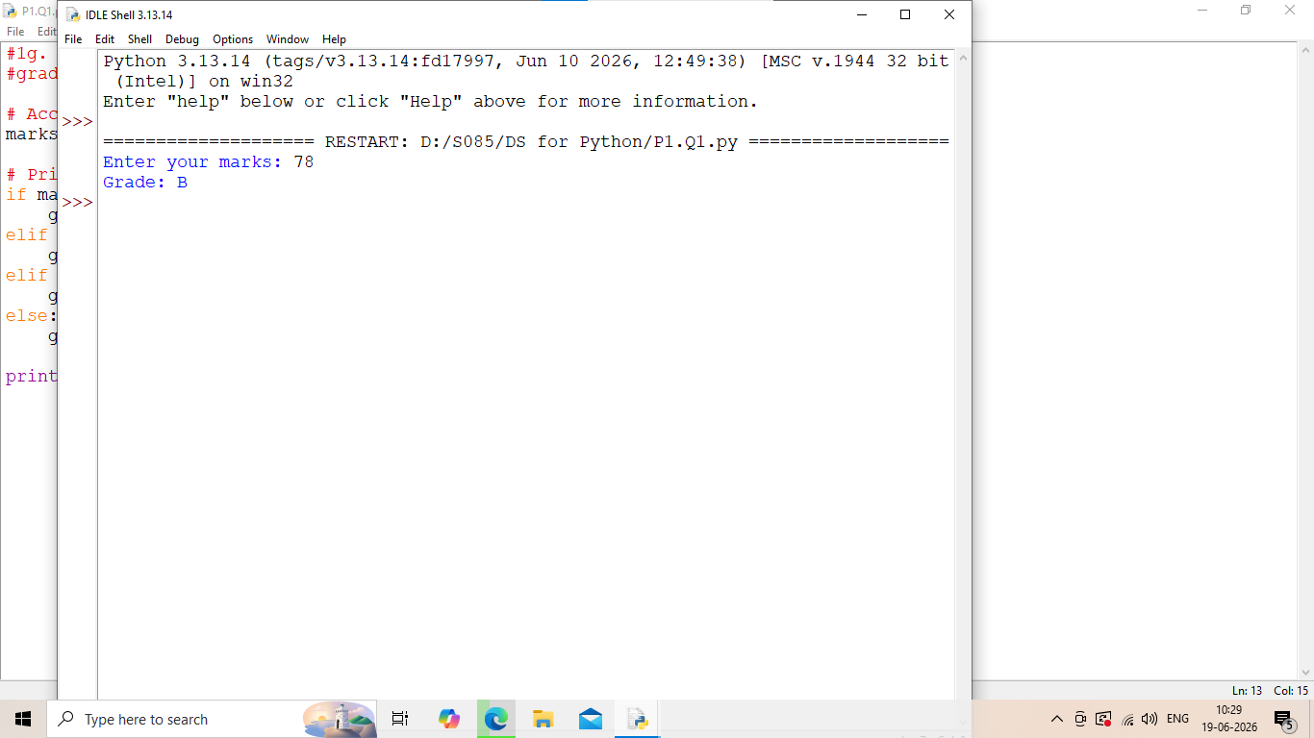

1h. Write a Python program using a loop that prints the square of numbers from 1 to 10, accepts 5 numbers from the user and prints how many are even.
